**Presenting Results Exercises**

**Saturday AM, June 4, 2011**

1. The two figures below were taken from a report of the uninsured in Illinois, based on an analysis of the Annual Social and Economic Supplement (March Supplement) of the Current Population Survey (Uninsured Rates for the Year 2001). Write a short narrative in the box provided to help your audience interpret the chart.

**Figure A: Number of Uninsured Persons in Illinois by Race/Ethnicity, 2001**

**Exercise 4 Continued**

**Figure B: Percent Uninsured by Age and US Citizenship, Illinois 2001**



1. Given the data below about breastfeeding duration and exclusivity by race in Illinois, please create a chart that clearly communicates these results. Apply any relevant design principles that we discussed during this morning’s lecture. Generate a rough sketch by hand.

**Table 1:** Patterns of Breastfeeding for Illinois Women at Multiple Timepoints after

Delivery, PRAMS 2008

|  |  |  |  |  |
| --- | --- | --- | --- | --- |
| **Race/**  **Ethnicity** | **Breastfeeding Status** | **Timepoint** | | |
| **Shortly After Delivery** | **2 Weeks After Delivery** | **12 Weeks After Delivery** |
| Overall | Exclusively Breastfeeding | 77% | 41% | 24% |
|  | Non-exclusively breastfeeding | 0% | 30% | 23% |
|  | Not breastfeeding | 23% | 29% | 53% |
|  |  |  |  |  |
| White, NH | Exclusively Breastfeeding | 78% | 51% | 31% |
|  | Non-exclusively breastfeeding | 0% | 22% | 20% |
|  | Not breastfeeding | 22% | 27% | 49% |
|  |  |  |  |  |
| Black, NH | Exclusively Breastfeeding | 54% | 25% | 12% |
|  | Non-exclusively breastfeeding | 0% | 23% | 15% |
|  | Not breastfeeding | 46% | 52% | 73% |
|  |  |  |  |  |
| Hispanic | Exclusively Breastfeeding | 86% | 33% | 18% |
|  | Non-exclusively breastfeeding | 0% | 47% | 32% |
|  | Not breastfeeding | 14% | 20% | 50% |
|  |  |  |  |  |
| Asian | Exclusively Breastfeeding | 97% | 45% | 30% |
|  | Non-exclusively breastfeeding | 0% | 50% | 40% |
|  | Not breastfeeding | 3% | 5% | 30% |

Other related information that you may or may not choose to incorporate in your graphic:

**Related *Healthy People 2020* Breastfeeding Objectives:**

* 81.9% of mothers breastfeed in the early postpartum period
* 60.5% of mothers breastfeed at 6 months of age
* 34.1% of mothers breastfeed at 1 year of age
* 44.3% of mothers exclusively breastfeed through 3 months of age
* 23.7% of mothers exclusively breastfeed through 6 months of age

**Number of Annual Births in Illinois = ~170,000**

***(blank space for sketching)***

**Question #2 *(blank space for sketching)***

1. Describe the strengths and weaknesses of the following tables and charts. Suggest ways that each could be improved.

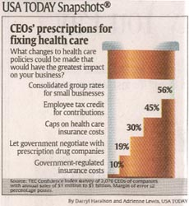

1. USA Today Health Snapshot
2. Womendeliver.org summary of 2009 Report by UNFPA and the Guttmacher Institute called: "Adding It Up: The Costs and Benefits of Investing in Family Planning and Maternal and Newborn Health."

**As the report says, we need to improve maternal and newborn care, and that would require more than doubling what we spend now.**

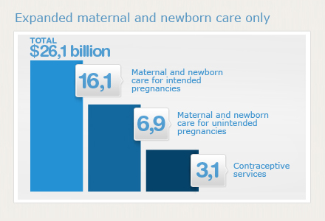

**But if we spent more on contraception, and still gave mothers and newborns the care they need, the total costs actually go down.**

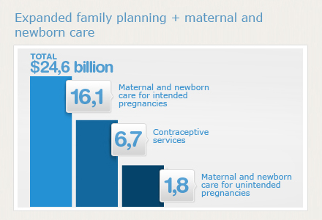

Obtained from: <http://www.womendeliver.org/updates/entry/new-video-highlights-adding-it-up-report-findings/>

1. Original graphic from 2009 Report by UNFPA and the Guttmacher Institute called: "Adding It Up: The Costs and Benefits of Investing in Family Planning and Maternal and Newborn Health."



1. **Figure 4.25. Women who completed a pregnancy in the last 12 months who first received prenatal care in the first trimester for selected States, by race, ethnicity, and education, 2005**

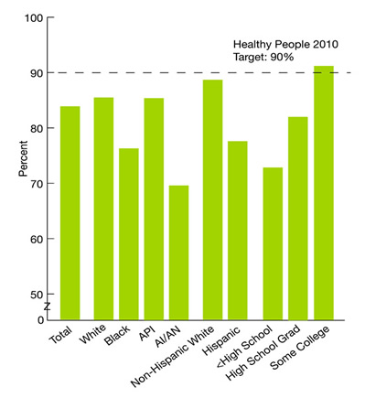

**Key:** AI/AN = American Indian or Alaska Native; API = Asian or Pacific Islander.  
**Source:** Centers for Disease Control and Prevention, National Center for Health Statistics, National Vital Statistics System-Natality, 2005.  
**Reference population:** Women with live births.  
**Note:** Data for 2005 include the 39 reporting areas (37 States, DC, and New York City) that used the 1989 revision of the US Standard Certificate of Live Birth in 2005. Reporting areas that have adopted the 2003 revision are excluded because prenatal data based on the 2003 revision are not comparable with data based on 1989 and earlier revisions of the US Standard Certificate of Live Birth. More information on the measure specification can be found in the Measure Specifications Appendix. Further discussion of this measure can be found in the Residents of Rural Areas section.

Obtained from: <http://www.ahrq.gov/qual/nhdr08/Chap4c.htm>

**Increase by One-Third the Number of Youth and Adults Who Are Healthy and Avoid Risky Behaviors**

http://www.unitedwaydenton.org/images/leftNav_linkBG2.gif

By 2018, the percentage of youth who are healthy and avoiding risky behaviors will increase from 34 percent in 2005 to 45 percent in 2018—that means 1.9 million more healthy young people.

n

The percentage of adults (age 18 and older) who are healthy and avoiding risky behaviors will increase from 35 percent in 2005 to 47 percent by 2018—that means 29.2 million more healthy adults.

n

Achieving this goal requires us all to become more aware of health risks and the potential effects they have on ourselves and others, starting from before birth. Working to change policies and practices, such as by extending health care coverage, will also enable more people to live healthier lives.

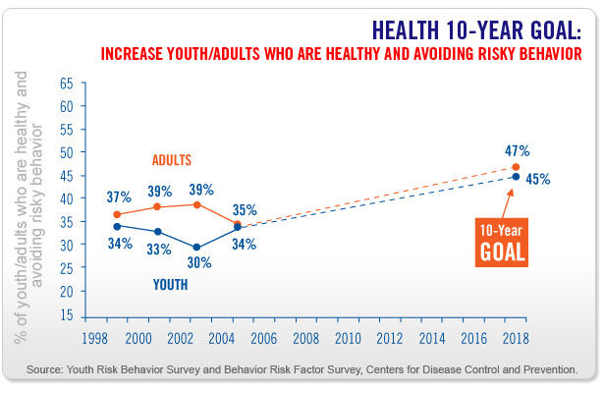

Obtained from: <http://www.unitedwaydenton.org/health.html>



1. **Adding It Up: The Costs and Benefits of Investing in Family**

**Planning and Maternal and Newborn Health: http://www.guttmacher.org/pubs/AddingItUp2009.pdf**

